**POISON MODULE:**

module poi

implicit none

contains

subroutine calc_poison(psi,zeta,m)

integer :: i,j,m

real::beta = 1.5

real :: b

real,dimension(101,101) :: psi

real,dimension(101,101) :: zeta

real,dimension(101,101) :: g

real,dimension(101,101) :: k

real,dimension(101,101) :: ps

b = 2.1e-11

m = 0

do i =1,100

do j =1,100

k(i,j)=0

end do

end do

do

do i =1,100

do j =1,100

g(i,j)=k(i,j)

end do

end do

do i = 2,99

do j = 2,99

k(i,j) = (zeta(i+1,j)+zeta(i-1,j)+zeta(i,j-1)+zeta(i,j+1)-4*zeta(i,j))/(20*1000)**2

end do

end do

if ( k(2,2)-g(2,2) <= 0.000001) exit

end do

do

m=m+1

do i =1,100

do j =1,100

g(i,j)=psi(i,j)

end do

end do

do i = 2,99

do j = 2,99

psi(i,j)=beta*(g(i+1,j)+psi(i-1,j)+g(i,j+1)+psi(i,j-1)-b*0.5*(zeta(i+1,j)-zeta(i-1,j))*(20*1000)+5*0.5*(k(i+1,j)-k(i-1,j))*(20*1000))/4+(1-beta)*g(i,j)

end do

end do

if ( psi(2,2)-g(2,2) <= 0.000001) exit

end do

print*,m

end subroutine

end module

**MAIN PROGRAM:**

! Program to moving non-divergent barotropic vorticity in first Time Evolution.

! Record of Revisions

! Date Programmer Description of change

! ===== ========== =====================

! 10/04/2021 Nithish Kumar Sriramoju Original Code

program l

use poi

implicit none

!!!!!!!!!!!!!!!!!!!!!!!!!!!!!!!!!!!!!!!!!!!!!!!!

! intiating variables

integer::i,j,n

real, dimension(101,101) :: psi

real, dimension(101,101) :: psi1

real, dimension(101,101) :: chi

n = 0

!!!!!!!!!!!!!!!!!!!!!!!!!!!!!!!!!!!!!!!!!!!!!!!!!!!!!!!!

! reading stream funtion values fro text file

open (1,file = 'poisson.txt',status = 'old')

do i = 1,101

read(1,*) ( psi(i,j), j=1,101 )

end do

!!!!!!!!!!!!!!!!!!!!!!!!!!!!!!!!!!!!!!!!!!!!!!!!!!!!!!!!

do i = 1,101

do j=1,101

psi1(i,j)=0

end do

end do

!!!!!!!!!!!!!!!!!!!!!!!!!!!!!!!!!!!!!!!!!!!!!!

! calling poisson solver

call calc_poison(chi,psi,n)

!!!!!!!!!!!!!!!!!!!!!!!!!!!!!!!!!!!!!!!!!!!!!!!!!!!!!!!!!!!!!!

! evolving stream function

do i = 2,99

do j = 2,99

psi1(i,j) = psi(i,j)+480*chi(i,j)

end do

end do

!!!!!!!!!!!!!!!!!!!!!!!!!!!!!!!!!!!!!!!!!!!!!!!!!!!!!!!!!!!!!!!!!

! writing values of evolved stream function

open(4,file = 'psi1.txt', status = 'unknown')

do i = 1,101

write(4,*) ( psi1(i,j), j=1,101 )

end do

end program

**This program is extended up to 1000 steps to get following results:**

**At t = 0;**

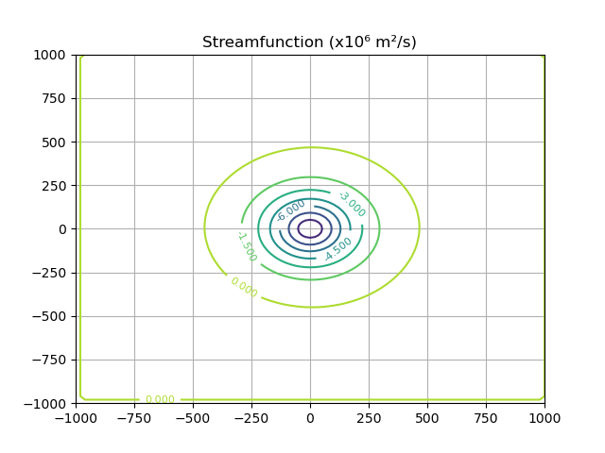

**At t = 0.133h**

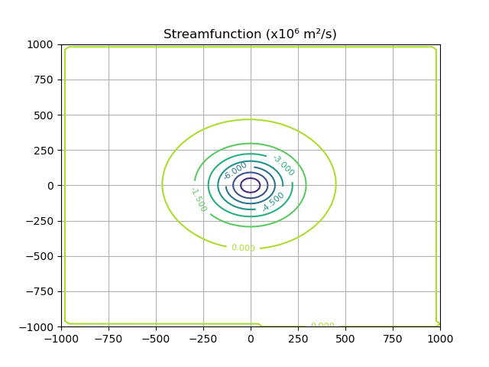

**At t = 1.33h**

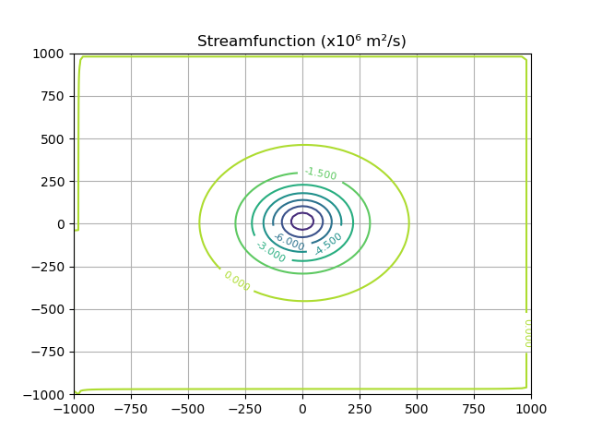

At t = 6.66h

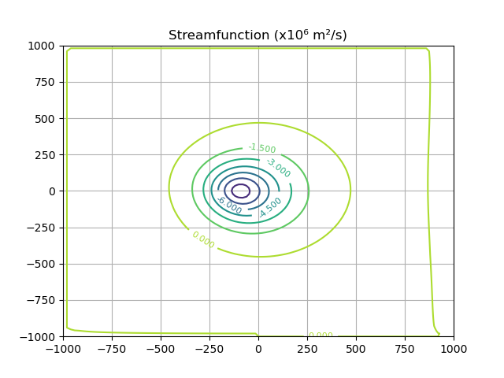

At t = 13.33h

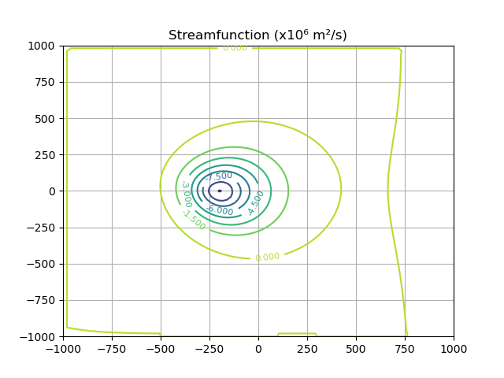

At t = 26.66h

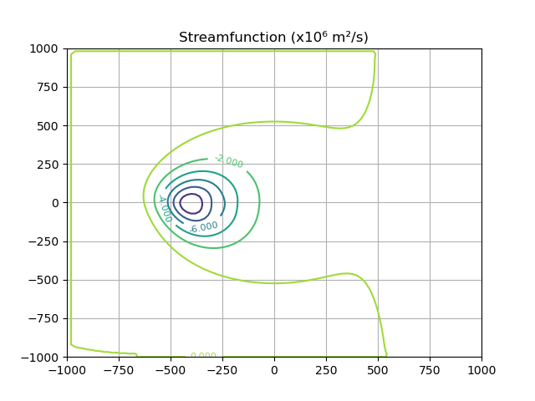

At t = 40h

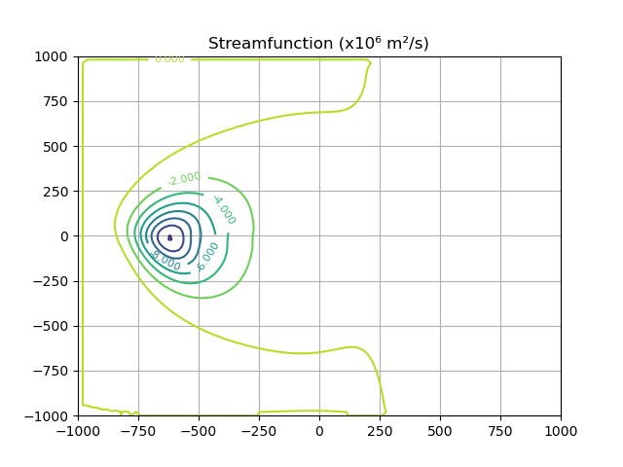

At t = 53.33h

